Virtual Server

🖥️ What is a Virtual Server?
# Source: Chatgpt (GPT-5-Mini) at [1/16/2026]
A Virtual Server is a software-based server that runs on a physical machine but behaves like a separate, independent server.
📌 Think of it as one computer running multiple mini-servers, each with its own operating system and resources.

🧠 How It Works
# Source: Chatgpt (GPT-5-Mini) at [1/16/2026]
- A physical machine (called a host) uses software like a hypervisor to run multiple virtual machines (VMs).
- Each virtual server can run its own OS, apps, and services, just like a real physical server.
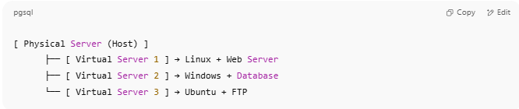
[ Physical Server (Host) ]
├── [ Virtual Server 1 ] → Linux + Web Server
├── [ Virtual Server 2 ] → Windows + Database
└── [ Virtual Server 3 ] → Ubuntu + FTP

🧩 Virtual Server vs Physical Server
# Source: Chatgpt (GPT-5-Mini) at [1/16/2026]
Feature | Virtual Server | Physical Server
Runs on | Shared physical hardware (host machine) | Own dedicated hardware
Flexibility | Easily cloned, backed up, or moved | Harder to scale or duplicate
Cost | More cost-effective | More expensive
Isolation | Each VM is separate and secure | Not applicable

🧰 Technologies Used
# Source: Chatgpt (GPT-5-Mini) at [1/16/2026]
Tool/Platform | Purpose
VMware ESXi | Enterprise virtualization (hypervisor)
VirtualBox | Desktop virtualization tool (Oracle)
KVM / QEMU | Linux-based virtual server environments
Proxmox | Open-source VM + container hosting platform
Hyper-V | Microsoft's virtualization platform

🚀 Use Cases for Virtual Servers
# Source: Chatgpt (GPT-5-Mini) at [1/16/2026]

Use Case | Why Use Virtual Server?
💻 Web hosting | Host multiple sites on one physical server
🔄 Testing & Development | Isolate environments (Windows, Linux, etc.)
🛡️ Security Sandboxing | Run untrusted apps in isolated virtual space
🎓 Learning Labs | Students can practice without harming systems
☁️ Cloud Services | VPS, AWS EC2, Azure VMs are virtual servers

✅ Summary
# Source: Chatgpt (GPT-5-Mini) at [1/16/2026]
Feature | Description
Purpose | Simulate a full server in a software environment
Runs on | A physical host machine
Tools used | VMware, VirtualBox, Hyper-V, etc.
Benefits | Flexible, scalable, cost-efficient
Used in | Web hosting, dev/test, cloud platforms

